OPERATING SYSTEM

Course code: CSE 316
Section: K18GE



Submitted by:-
Name: Nurul Haque
Roll No.: 48
Registration No.: 11903516
E-mail :- nurulhaque274@gmail.com
GitHub Link: https://github.com/nurulhaque274/Operating-System

Submitted to:-
Name of the faculty: Milanjit Kaur

Department of Intelligent Systems
School of Computer Science Engineering
Lovely Professional University, Jalandhar
APRIL-2020

Program code.
#include<stdio.h>
void rr(int no,int remt[10],int Cur_t,int arT[10], int bsT[10]);
int main()
{
int Proc_no, j,no,CurT,RemProc,indicator,time_quan, wait,tut, arT[10], bsT[10],remt[10],x=1;
indicator = 0;
wait = 0;
tut = 0;
printf("\nEnter number of processes ");
scanf("%d",&no);
RemProc = no;
printf("\nEnter the arrival time and burst time of the processes\n");
for(Proc_no = 0;Proc_no < no;Proc_no++)
{
printf("\nProcess P%d\n",Proc_no+1);
printf("Arrival time = ");
scanf("%d",&arT[Proc_no]);
printf("Burst time = ");
scanf("%d",&bsT[Proc_no]);
remt[Proc_no]=bsT[Proc_no];
}
printf("The details of time quantum are as follows:\n");
printf("The time quantum for first round is 6.\n");
time_quan=6;
CurT=0;
for(Proc_no=0;RemProc!=0;)
{
if(remt[Proc_no]<=time_quan && remt[Proc_no]>0)
{
CurT+=remt[Proc_no];
remt[Proc_no]=0;
indicator=1;
}
else if(remt[Proc_no]>0)
{
remt[Proc_no]-=time_quan;
CurT+=time_quan;
}
if(remt[Proc_no]==0 && indicator==1)
{ printf("%d",Proc_no);
RemProc--;
printf("P %d",Proc_no+1);
printf("\t\t\t%d",CurT-arT[Proc_no]);
printf("\t\t\t%d\n",CurT-bsT[Proc_no]-arT[Proc_no]);
wait+=CurT-arT[Proc_no]-bsT[Proc_no];
tut+=CurT-arT[Proc_no];
indicator=0;
}
if(Proc_no==no-1){
x++;
if(x==2){
Proc_no=0;
time_quan=10;
printf("\nThe time quantum for second round is 10. \n");
}
else{
break;
}
}
else if(CurT >= arT[Proc_no+1]){
Proc_no++;
}
else{
Proc_no=0;
}
}
rr(no,remt,CurT,arT,bsT);
return 0;
}
void rr(int no,int remt[10],int Cur_t,int arT[10], int bsT[10]){
float avg_wait,avg_tut;
int i,j,n=no,temp,btime[20],Proc_no[20],w_time[20],tut_t[20],total=0,loc;
printf("\nThird round with least burst time.\n");
for(i=0;i<n;i++)
{
btime[i]=remt[i];
w_time[i]=Cur_t-arT[i]-btime[i];
Proc_no[i]=i+1;
}
for(i=0;i<n;i++)
{
loc=i;
for(j=i+1;j<n;j++)
{
if(btime[j]<btime[loc]){
loc=j;
}
}
temp=btime[i];
btime[i]=btime[loc];
btime[loc]=temp;
temp=Proc_no[i];
Proc_no[i]=Proc_no[loc];
Proc_no[loc]=temp;
}
for(i=1;i<n;i++)
{
for(j=0;j<i;j++){
w_time[i]+=btime[j];
}
total+=w_time[i];
}
avg_wait=(float)total/n;
total=0;
printf("________________________________________________________________");
printf("\nProcess\t\tBurst time\t\twaiting time\t\tTurnaround Time\n");
printf("________________________________________________________________");
for(i=0;i<n;i++)
{
tut_t[i]=btime[i]+w_time[i];
total=total + tut_t[i];
printf("\nP%d\t\t\t%d\t\t\t%d\t\t\t%d",Proc_no[i],btime[i],w_time[i],tut_t[i]);
}
printf("\n________________________________________________________________\n");
avg_tut=(float)total/n;
printf("\n\nAverage waiting time = %f",avg_wait);
printf("\nAverage turnaround time = %f\n",avg_tut);
}

PROBLEM IN TERMS OF OPERATING SYSTEM
Ques. 2. Considering the arrival time and burst time requirement of the process the scheduler schedules the processes by interrupting the processor after every 6 units of time and does consider the completion of the process in this iteration. The scheduler than checks for the number of process waiting for the processor and allots the processor to the process but interrupting the processor every 10 unit of time and considers the completion of the processes in this iteration. The scheduler checks the number of processes waiting in the queue for the processor after the second iteration and gives the processor to the process which needs more time to complete than the other processes to go in the terminated state.
The inputs for the number of requirements, arrival time and burst time should be provided by the user.
Consider the following units for reference.
Process Arrival time Burst time
P1 0 20
P2 5 36
P3 13 19
P4 26 42
Develop a scheduler which submits the processes to the processor in the defined scenario, and compute the scheduler performance by providing the waiting time for process, turnaround time for process and average waiting time and turnaround time.

In the given problem we design a scheduler of Round Robin(RR). In Round-robin scheduling, each ready task runs turn by turn only in a cyclic queue for a limited time slice. This algorithm also offers starvation free execution of processes.

ALGORITHM:
- Take all the inputs from the user.
- Arrange the processes in two different queues.
- Put the two different queues into single queue according to arrival time and priority.
- Select that process which has minimum arrival time and minimum burst time.
- After completion of process, select next process which has minimum arrival time and minimum burst time.
- After completion of all processes, summarize the process with their completion time.

COMPLEXITY OF THE ALGORITHM:
The complexity of the scheduling algorithm is O(1).

CONSTRAINTS
- Round robin CPU scheduling algorithm cannot be implemented in real time operating system due to high context switching, large waiting time, large response time, large turnaround time and less throughput.
- The proposed algorithm improves all the drawbacks of round robin CPU scheduling algorithm.
- It reduces the problem of starvation and also implement the concept of aging.

Characteristics
- Round robin is a pre-emptive algorithm.
- The CPU is shifted to the next process after fixed interval time, which is called time quantum/time slice.
- The process that is preempted is added to the end of the queue.
- It is a real time algorithm which responds to the event within a specific time limit.
- Round robin is one of the oldest, fairest, and easiest algorithm.
- Widely used scheduling method in traditional OS.

Advantages
- It doesn't face the issues of starvation.
- All the jobs get a fair allocation of CPU.
- It deals with all process without any priority.
- Once a process is executed for a specific set of the period, the process is preempted, and another process executes for that given time period.
- Allows OS to use the Context switching method to save states of preempted processes.
- It gives the best performance in terms of average response time.

Disadvantages
- If slicing time of OS is low, the processor output will be reduced.
- This method spends more time on context switching
- Its performance heavily depends on time quantum.
- Priorities cannot be set for the processes.
- Round-robin scheduling doesn't give special priority to more important tasks.
- Decreases comprehension
- Lower time quantum results in higher the context switching overhead in the system.

CODE SNIPPET:
for(i=0;i<n;i++)
{
loc=i;
for(j=i+1;j<n;j++)
{
if(btime[j]<btime[loc]){
loc=j;
}
}
temp=btime[i];
btime[i]=btime[loc];
btime[loc]=temp;
temp=Proc_no[i];
Proc_no[i]=Proc_no[loc];
Proc_no[loc]=temp;
}
for(i=1;i<n;i++)
{
for(j=0;j<i;j++){
w_time[i]+=btime[j];
}
total+=w_time[i];
}

TEST CASE
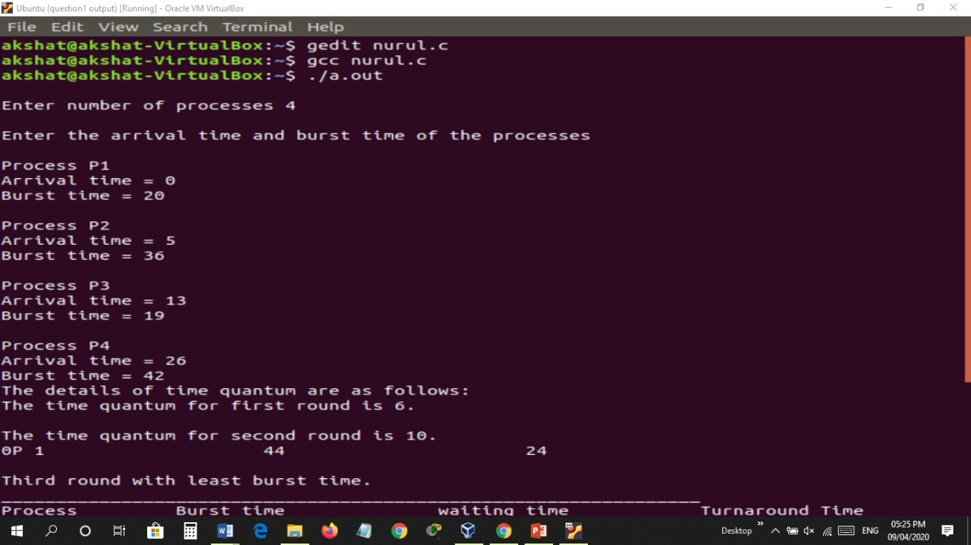

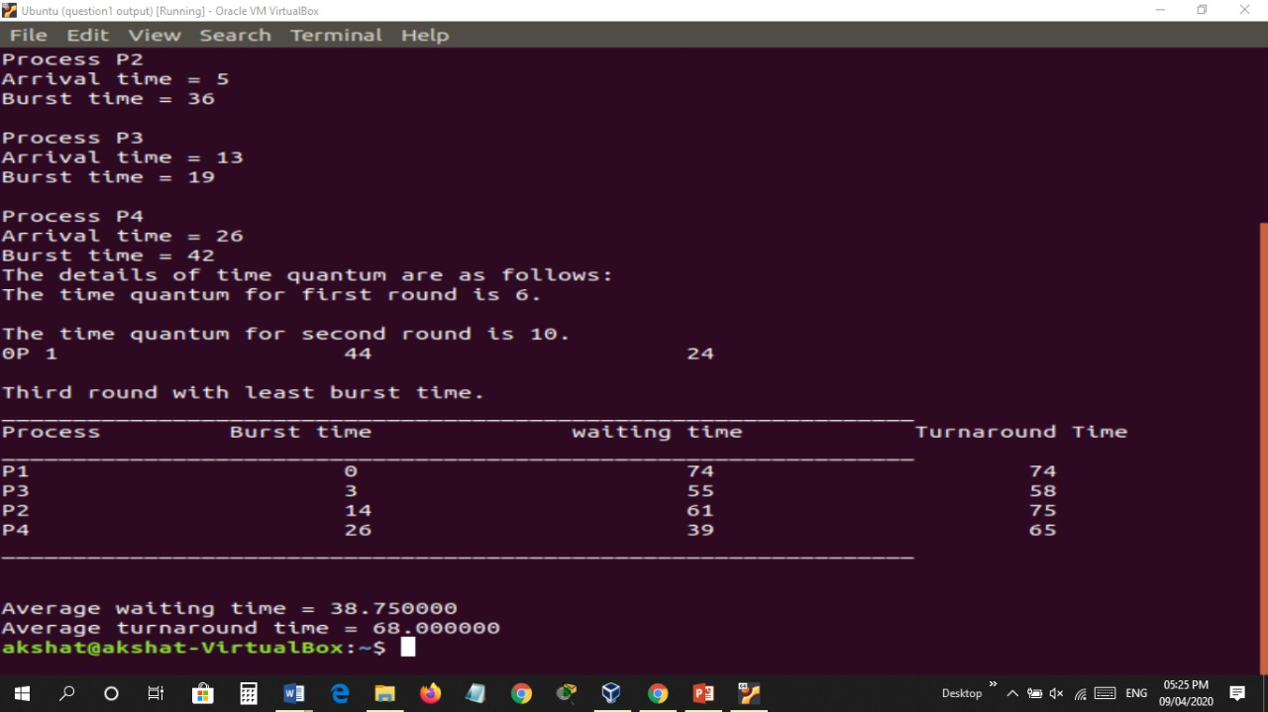

EXPLANATION
Consider this following three processes:-
Process Queue Burst Time
P1 4
P2 3
P3 5
Given Time Quantum is 2 sec.
Step 1) The execution begins with process P1, which has burst time 4. Here, every process executes for 2 seconds. P2 and P3 are still in the waiting queue.
Step 2) At time =2, P1 is added to the end of the Queue and P2 starts executing.
Step 3) At time=4 , P2 is preempted and add at the end of the queue. P3 starts executing.
Step 4) At time=6 , P3 is preempted and add at the end of the queue. P1 starts executing.
Step 5) At time=8 , P1 has a burst time of 4. It has completed execution. P2 starts execution.
Step 6) P2 has a burst time of 3. It has already executed for 2 interval. At time=9, P2 completes execution. Then, P3 starts execution till it completes.
Step 7) Let's calculate the average waiting time.
Wait time :-
P1 = 0 + 4 = 4
P2 = 2 + 4 = 6
P3 = 3+4 = 7

